Northeastern Illinois University

07/24/204

**Design Document**

**Timesheet & Leave Management System**

Anusha Bestha

Jyoti Behera

Lakshmi Vasundhara Tammisetty

Sumanth Tadikonda

Sushma Adepu

# 

DOCUMENT RELEASE NOTICE

**Document Details:**

|  |  |  |
| --- | --- | --- |
| **Name** | **Version No.** | **Description** |
| Design Document | 1.0 | This document for **Timesheet & Leave Management System** Of **Northeastern Illinois University** includes the design models used and respective diagrams for the system. |

**Revision Details**

|  |  |  |  |
| --- | --- | --- | --- |
| **Action taken**  **(Add/Del/Change)** | **Preceding Page No.** | **New Page No.** | **Revision Description** |
|  |  |  |  |
|  |  |  |  |
|  |  |  |  |
|  |  |  |  |
|  |  |  |  |

Table of Contents

1 Introduction 6

1.1 Purpose 6

1.2 Scope 6

1.3 Definitions, Acronyms, and Abbreviations 6

1.4 References 6

1.5 Overview 7

2 Use Cases 7

2.1 Actors 7

2.1.1 Manager – 7

An NEIU staff member with the capability of approving/rejecting either timesheets or leave requests from student workers. 7

2.1.2 Student worker– 7

A prospective (admitted), current student who works in any of the departments at Northeastern Illinois University. 7

2.2 List of Use cases 7

2.2.1 Module 0 – Student Worker Profile 7

2.2.2 Module 1- Login 7

2.2.3 Module 2- Timesheet Management 7

2.2.4 Module 3-Leave Request Management 8

2.2.5 Module 4- Approval/Rejection of Timesheets 8

2.2.6 Module 5- Approval/Rejection of Leave Requests 8

2.3 Use case Diagrams 8

2.3.1 Module 0 – Student Worker Profile 8

2.3.2 Module 1- Login 9

2.3.3 Module 2- Timesheet Management & Module 4- Approval/Rejection of Timesheets 9

2.3.4 Module 3-Leave Request Management 10

2.3.5 Module 5- Approval/Rejection of Leave Requests 10

2.4 Usecases 11

2.4.1 Usecase 0- Create Student Worker Profile 11

2.4.2 Usecase 1- View Student Worker Profile 12

2.4.3 Usecase 2- Edit Student Worker Profile 13

2.4.4 Usecase 3- Activate Student Worker Profile 15

2.4.5 Usecase 4- Deactivate Student Worker Profile 16

2.4.6 Usecase 5- Login 18

2.4.7 Usecase 6- Forget password 19

2.4.8 Usecase 7- Change password 21

2.4.9 Usecase 8 – Submit Timehseets 22

2.4.10 Usecase 9 – Create Timehseets 23

2.4.11 Usecase 10 – Edit Timehseets 24

2.4.12 Usecase 11– View Timehseets 24

2.4.13 Usecase 12 – Delete Timehseets 25

2.4.14 Usecase 13 – Request New Leave 26

2.4.15 Usecase 14 – View Leave Request 27

2.4.16 Usecase 15 – Edit leave Request 28

2.4.17 Usecase 16– Approve Timehseets 30

2.4.18 Usecase 17 – Reject Timesheets 31

2.4.19 Usecase 18 - View Timesheets 32

2.4.20 Usecase 19 - Approve Leave Requests 33

2.4.21 Usecase 20 - Reject Leave Requests 34

3 Class Diagram 36

4 Dynamic Models 37

4.1 Activity Diagrams 37

4.1.1 *Activity Diagram 0* – Create Student Worker Profile 37

4.1.2 Activity Diagram 1– View Student Worker Profile 38

4.1.3 Activity Diagram 2 – Edit Student Worker Profile 39

4.1.4 Activity Diagram 3 – Activate Student Worker Profile 40

4.1.5 Activity Diagram 4 – Deactivate Student Worker Profile 41

4.1.6 Activity Diagram 5 – Login 42

4.1.7 Activity Diagram 6 – Change password 43

4.1.8 Activity Diagram 7 – Forget Passowrd 44

4.1.9 Activity Diagram 8– Timesheet 45

*4.1.10* Activity Diagram 9– Leave Request 46

4.1.11 Activity Diagram 10 – Approve Leave Request 47

4.1.12 Activity Diagram 11 – Reject Leave Request 48

4.2 Sequence Diagrams 49

4.2.1 Sequence Diagram 0 – Manager View & Edit Profile(Module 0) 49

4.2.2 Sequence Diagram 1 – Student worker View & Edit Profile(Module 0) 50

4.2.3 Sequence Diagram 2 – Login(Module 1) 51

4.2.4 Sequence Diagram 3 – Timesheets(Module 2&4) 52

4.2.5 Sequence Diagram 4- Leave Management(Module 3) 53

4.2.6 Sequence Diagram 5 – Approve/Reject Leave Requests(Module 5) 54

5 Data Design 55

*5.1* *Entity Relationship Diagram* 55

6 Non Functional Requirements 55

6.1 Ease of Use 55

6.2 Reliability 55

6.3 Security 55

7 Supplementary Documentation 55

7.1 UML Diagrams 55

7.2 Entity Realtionship Diagram 55

Software Design Document

# Introduction

The Software Design Document is a document to provide documentation which will be used to aid in software development by providing the details for how the software should be built.

## Purpose

The purpose of the TLS Software Design Document is to provide a description of the design of a TLS system fully enough to allow for software development to proceed with an understanding of what is to be built and how it is expected to built. The Software Design Document provides information necessary to provide description of the details for the software and system to be built.

Within this Software Design Document are narrative and graphical documentation of the software design for the TLS project including use case models, sequence diagrams, and other supporting requirement information of TLS system.

## Scope

TLS Software Design Document is for a base level system which will work as a proof of concept for the use of building TLS system which provides a base level of functionality to show feasibility for large scale production use of TLS System. This Software Design is focused on the base level and critical parts of the TLS system.

## Definitions, Acronyms, and Abbreviations

This section provides a list of the acronyms and abbreviations used in this document and the meaning of each.

|  |  |
| --- | --- |
| **Acronyms/Abbreviations** | **Meaning** |
| IDE | Integrated Development Environment |
| TLS | Timesheet & Leave Management System |
| UML | Unified Modeling Language |
| T&L | Timesheet & Leave |
| SRS | Software Requirements Specification |

## References

Below is the list of the references that were used in preparation of this document in order of importance to the end user

1. Timesheet & Leave Management System_SRS.doc
2. T & L System Use case Diagram.odt
3. T&L System Use Cases Document.docx
4. T&L System Other UML Diagrams.docx

## Overview

The Software Design Document is divided into 7 sections with various subsections. The sections of the Software Design Document are:

1. Introduction
2. Use Cases
3. Design Overview
4. Data Design
5. Dynamic Model
6. Non-functional Requirements
7. Supplementary Documentation

# Use Cases

## Actors

There are two distinct user access levels Manager and Student Worker are defined in this system. Timesheet & Leave Management system’s activities are completely dependent on the user login. If the user login as a manager he is directed to manager’s home page which displays the menu intended for him and similarly to the student worker. One access level features are not displayed to other access level.

### Manager –

### An NEIU staff member with the capability of approving/rejecting either timesheets or leave requests from student workers.

### Student worker–

### A prospective (admitted), current student who works in any of the departments at Northeastern Illinois University.

## List of Use cases

### Module 0 – Student Worker Profile

1. Create Student Profile
2. View Student Profile
3. Edit Student Profile
4. Delete Student Profile
5. Activate Student Profile
6. Deactivate Student Profile

### Module 1- Login

1. Login
2. Change Password
3. Forgot Password

### Module 2- Timesheet Management

1. Create Timesheet
2. View Timesheet
3. Edit Timesheet
4. Delete Timesheet
5. Submit Timesheet

### Module 3-Leave Request Management

1. Create Leave request
2. View Leave request
3. Edit Leave request

### Module 4- Approval/Rejection of Timesheets

1. View All Timesheets
2. Approve Timesheets
3. Reject Timesheets

### Module 5- Approval/Rejection of Leave Requests

1. View All Leave requests
2. Approve Leave requests
3. Reject Leave requests

## Use case Diagrams

### Module 0 – Student Worker Profile

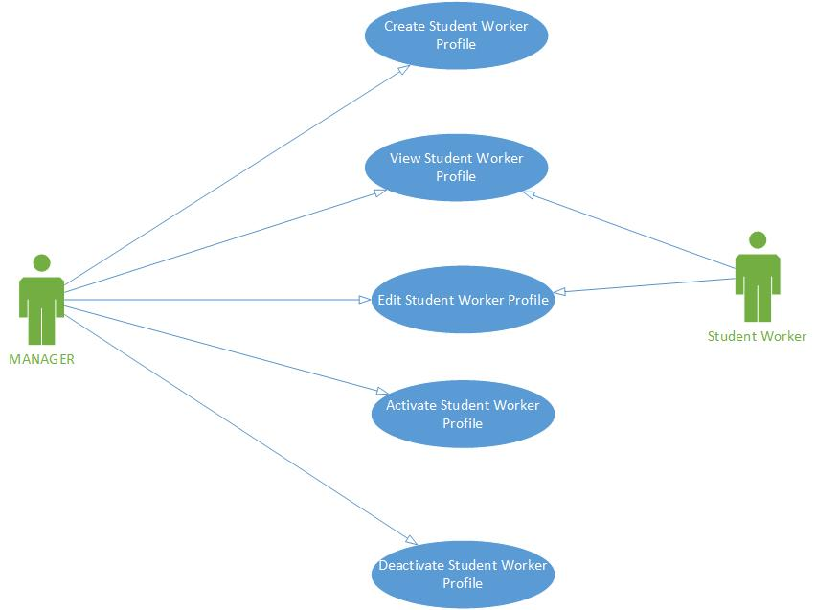

### Module 1- Login

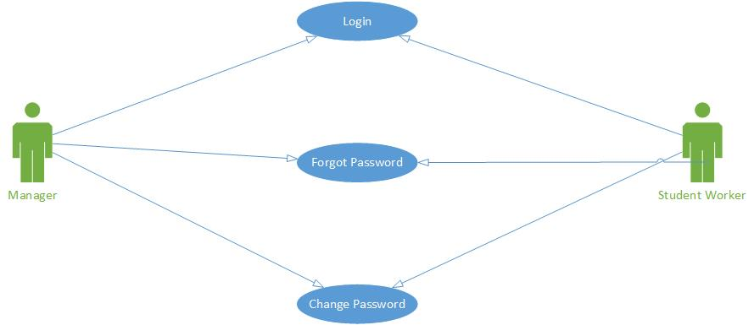

### Module 2- Timesheet Management & Module 4- Approval/Rejection of Timesheets

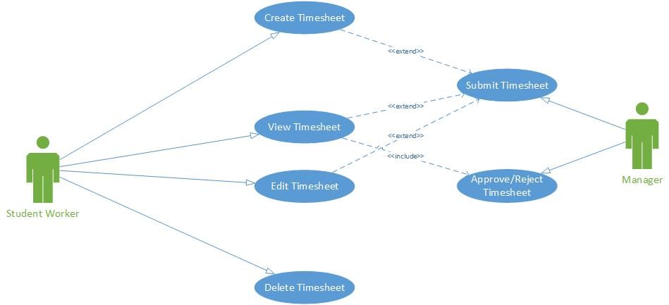

### Module 3-Leave Request Management

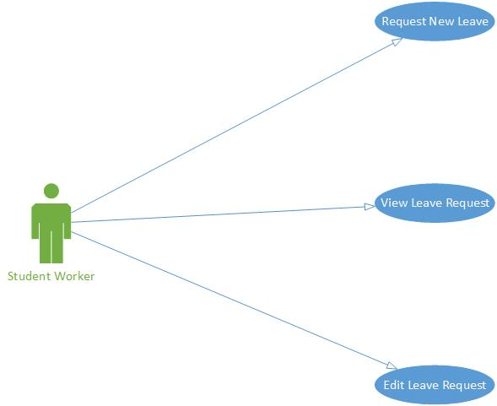

### Module 5- Approval/Rejection of Leave Requests

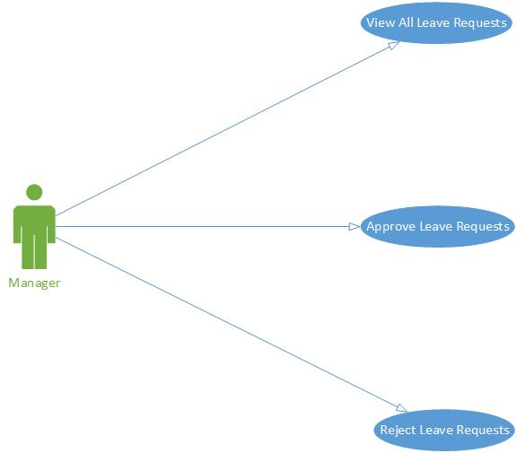

## Usecases

### Usecase 0- Create Student Worker Profile

|  |  |  |  |
| --- | --- | --- | --- |
| Use Case ID: | 0 | | |
| Use Case Name: | Create Student Worker Profile | | |
| Use Case Diagram Reference: | Module 0 – Student Worker Profile | | |
| Date Created: | 11/06/2014 | Date Last Updated: | N/A |
| Actors: | Manager | | |
| Description: | Manager of a particular student worker creates a profile with basic details that are mentioned below  First Name  Last Name  NEIU ID  NEIU Username  NEIU Email Id  Job Position | | |
| Preconditions: | Manager has to be logged into the system using username and password. | | |
| Post conditions: | After creating this profile manager provides a default password to the student worker to be used for the first time access to the system. | | |
| Normal Flow: | 1.0.Create Student Profile   1. Login to the Timesheet & Leave Management system using username and password provided to the manager. 2. Click on “Create Student Profile” menu item. 3. Enter all the required fields like First Name, Last Name, NEIU Username, NEIU ID, and Email Id and select job from Job Position drop down menu. 4. If you are satisfied or completed with filling details, click on “Submit”. 5. Else click on Reset to clear all the fields. | | |
| Alternative Flows: | None | | |
| Exceptions: | None | | |
| Includes: | None | | |
| Priority: | High | | |
| Frequency of Use: | Not more frequently (Assumption 2 per day).Depends on the hiring people for that department. | | |
| Business Rules: | None | | |
| Special Requirements: | None | | |
| Assumptions: | 1. Manager profiles are created already by an administrator i.e. his/her username and password are set. 2. Student worker is hired by that department manager according to the department hiring requirements. | | |
| Notes and Issues: | None | | |

### Usecase 1- View Student Worker Profile

|  |  |  |  |
| --- | --- | --- | --- |
| Use Case ID: | 1 | | |
| Use Case Name: | View Student Worker Profile | | |
| Use Case Diagram Reference: | Module 0 – Student Worker Profile | | |
| Date Created: | 11/06/2014 | Date Last Updated: | N/A |
| Actors: | 1. Manager 2. Student Worker | | |
| Description: | Manager or a student worker can view profile created by manager at any time they want. | | |
| Preconditions: | Manager or a student worker has to be logged into the system using username and password. | | |
| Post conditions: | After logging to the system, either student worker or manager can view student worker profile | | |
| Normal Flow: | 1.0.View Student Profile - Manager   1. Login to the Timesheet & Leave Management system using username and password provided to the manager. 2. Click on “View Student Profiles”. 3. Displays the entire student workers profile list.   1.1. View Student profile – Student worker   1. Login to the Timesheet & Leave Management system using username and password provided to the student. 2. Click on “My Account”. 3. In the dropdown select “View Profile” 4. Displays the student profile with the details First Name, Last Name, NEIU Username, NEIU ID, Email Id and Job Position. | | |
| Alternative Flows: | None | | |
| Exceptions: | **1.2.E.1 if Student profile is not available**   1. System informs the user that no student profile is available with that first name. 2. Use case terminates. | | |
| Includes: | None | | |
| Priority: | Low | | |
| Frequency of Use: | Not more frequently (Assumption 2 per day). | | |
| Business Rules: | None | | |
| Special Requirements: | None | | |
| Assumptions: | 1. Manager profiles are created already by an administrator i.e. his/her username and password are set. 2. Student worker profile is created by Manager. | | |
| Notes and Issues: | None | | |

### Usecase 2- Edit Student Worker Profile

|  |  |  |  |
| --- | --- | --- | --- |
| Use Case ID: | 2 | | |
| Use Case Name: | Edit Student Worker Profile | | |
| Use Case Diagram Reference: | Module 0 – Student Worker Profile | | |
| Date Created: | 11/06/2014 | Date Last Updated: | N/A |
| Actors: | 1. Manager 2. Student Worker | | |
| Description: | Manager or a student worker can edit profile created by manager at any time they want. | | |
| Preconditions: | Manager or a student worker has to be logged into the system using username and password. | | |
| Post conditions: | After logging to the system, either student worker or manager can edit student worker profile | | |
| Normal Flow: | 1.0.Edit Student Profile - Manager   1. Login to the Timesheet & Leave Management system using username and password provided to the manager. 2. Click on “View Student Profiles”. 3. Displays the entire student workers profile list. 4. Click on “Edit” link. 5. Modify the details like First Name, Last Name, NEIU Username, NEIU ID, and Email Id and select job from Job Position drop down menu 6. Click on “Submit”.   1.1. Edit Student profile – Student worker   1. Login to the Timesheet & Leave Management system using username and password provided to the student. 2. Click on “My Account”. 3. In the dropdown select “Edit Profile” 4. Displays the student profile with the details First Name, Last Name, NEIU Username, NEIU ID, Email Id and Job Position 5. Update the fields with new data. 6. Click on “Update” 7. Student profile is updated with new details | | |
| Alternative Flows: | None | | |
| Exceptions: | None | | |
| Includes: | None | | |
| Priority: | Low | | |
| Frequency of Use: | Not more frequently (Assumption 2 per day).Depends on the hiring people for that department. | | |
| Business Rules: | None | | |
| Special Requirements: | None | | |
| Assumptions: | 1. Manager profiles are created already by an administrator i.e. his/her username and password are set. 2. Student worker profile is created by Manager. | | |
| Notes and Issues: | Only few details of student worker profile can be edited by him like name, email id, phone number etc.,.Other details like role, funding, organization id are disabled | | |

### Usecase 3- Activate Student Worker Profile

|  |  |  |  |
| --- | --- | --- | --- |
| Use Case ID: | 3 | | |
| Use Case Name: | Activate Student Worker Profile | | |
| Use Case Diagram Reference: | Module 0 – Student Worker Profile | | |
| Date Created: | 11/06/2014 | Date Last Updated: | N/A |
| Actors: | Manager | | |
| Description: | Manager can activate a student worker profile from deactivation state. | | |
| Preconditions: | 1. Manager has to be logged into the system using username and password. 2. Student worker has to inform the manager that he is returning to work and request for activation of profile through email or personally. | | |
| Post conditions: | Student worker profile gets activated form deactivated state and use the system by logging in. | | |
| Normal Flow: | 1.0.Activate Student Profile   1. Login to the Timesheet & Leave Management system using username and password provided to the manager. 2. Click on “View Student Profiles”. 3. Displays the entire student workers profile list. 4. Click on “Activate/Deactivate” link. 5. If the profile is active, it gets deactivated once user clicks on the “Activate/Deactivate” link. 6. If the profile is not active, it gets activated once user clicks on the “Activate/Deactivate” link. | | |
| Alternative Flows: | None | | |
| Exceptions: | None | | |
| Includes: | None | | |
| Priority: | Medium | | |
| Frequency of Use: | Not more frequently (Assumption 2 per day).Depends on the hiring people for that department. | | |
| Business Rules: | None | | |
| Special Requirements: | None | | |
| Assumptions: | 1. Student worker is hired by that department manager according to the department hiring requirements. 2. During Deactivation state student worker is not authorized to use the Timesheet & Leave management system as he is not working for a particular period of time. | | |
| Notes and Issues: | 1. Activation State: Student worker is working 2. Deactivation State: Student worker is not working for a particular period of time like summer session and willing to work after that period of time. | | |

### Usecase 4- Deactivate Student Worker Profile

|  |  |  |  |
| --- | --- | --- | --- |
| Use Case ID: | 4 | | |
| Use Case Name: | Deactivate Student Worker Profile | | |
| Use Case Diagram Reference: | Module 0 – Student Worker Profile | | |
| Date Created: | 11/06/2014 | Date Last Updated: | N/A |
| Actors: | Manager | | |
| Description: | Manager can activate a student worker profile from deactivation state. | | |
| Preconditions: | 1. Manager has to be logged into the system using username and password. 2. Student worker has to inform the manager that he is not going to work for a particular period of time through email or personally. | | |
| Post conditions: | Student worker profile gets deactivated form activated state and user cannot use the system for that period of time of deactivation. | | |
| Normal Flow: | 1.0.DeActivate Student Profile   1. Login to the Timesheet & Leave Management system using username and password provided to the manager. 2. Click on “View Student Profiles”. 3. Displays the entire student workers profile list. 4. Click on “Activate/Deactivate” link. 5. If the profile is active, it gets deactivated once user clicks on the “Activate/Deactivate” link. 6. If the profile is not active, it gets activated once user clicks on the “Activate/Deactivate” link. | | |
| Alternative Flows: | None | | |
| Exceptions: | None | | |
| Includes: | None | | |
| Priority: | Medium | | |
| Frequency of Use: | Not more frequently (Assumption 2 per day).Depends on the hiring people for that department. | | |
| Business Rules: | None | | |
| Special Requirements: | None | | |
| Assumptions: | 1. Student worker is hired by that department manager according to the department hiring requirements. 2. During Deactivation state student worker is not authorized to use the Timesheet & Leave management system as he is not working for a particular period of time. | | |
| Notes and Issues: | 1. Activation State: Student worker is working 2. Deactivation State: Student worker is not working for a particular period of time like summer session and willing to work after that period of time. | | |

### Usecase 5- Login

|  |  |  |  |
| --- | --- | --- | --- |
| Use Case ID: | 5 | | |
| Use Case Name: | Login | | |
| Use Case Diagram Reference: | Module 1- Login | | |
| Date Created: | 11/06/2014 | Date Last Updated: | N/A |
| Actors: | 1. Manager 2. Student Worker | | |
| Description: | 1. Manager: Manager can use designated username and password that are already set to access the system. 2. Student worker: Student worker can use his/her NEIU port username and a default password that will be sent to him by manager for the first time access. After that he can change the password using “Change Password “feature in student worker profile. | | |
| Preconditions: | 1. Manager profiles are created already by an administrator i.e. his/her username and password are set. 2. Student worker is hired by that department manager according to the department hiring requirements and default password is sent to him/her for the first time users. 3. Student worker profile is created and has his/her own user name and password. | | |
| Post conditions: | After logging to the system successfully, users are redirected to their specific home pages with menu intended to them according to the operations that can perform using the system. | | |
| Normal Flow: | 1.0.Login   1. Go to the system home page, where login is provided. 2. Enter Username 3. Enter Password 4. Click on “Submit”. | | |
| Alternative Flows: | None | | |
| Exceptions: | 1.0.E.1.Invalid username   1. System informs user if the username is incorrect or unavailable. 2. Returns to the login page (Step 1) by resetting the fields.   1.0.E.1.Invalid password   1. System informs user if the password is incorrect. 2. Returns to the login page (Step 1) by resetting the fields. | | |
| Includes: | None | | |
| Priority: | High | | |
| Frequency of Use: | Frequently (Assumption 100 per day). | | |
| Business Rules: | None | | |
| Special Requirements: | None | | |
| Assumptions: | 1. Manager profiles are created already by an administrator i.e. his/her username and password are set. 2. Student worker is hired by that department manager according to the department hiring requirements and a profile is created for hm/her by the manager.. | | |
| Notes and Issues: | None | | |

### Usecase 6- Forget password

|  |  |  |  |
| --- | --- | --- | --- |
| Use Case ID: | 6 | | |
| Use Case Name: | Forget password | | |
| Use Case Diagram Reference: | Module 1 - Login | | |
| Date Created: | 11/06/2014 | Date Last Updated: | N/A |
| Actors: | 1. Manager 2. Student Worker | | |
| Description: | Both the student worker and manager can use this feature to reset their passwords if they forgot at any time. which should follow below restrictions: | | |
| Preconditions: | For this they have to provide their NEIU Username which is unique. | | |
| Post conditions: | New Password is updated and user can login using new password. | | |
| Normal Flow: | 1.0.Forgot Password   1. Go to the system home page, where login is provided. 2. Click on “Forgot Password” link. 3. In the new window enter username. 4. Click on “Submit”. 5. If the user name is available, user is asked to answer a security question. 6. Click on “Submit”. 7. If the security answer is correct, user is asked to enter new password and confirm new password. 8. After entering the new password and confirm password, click on “Submit” | | |
| Alternative Flows: | None | | |
| Exceptions: | 1.0.E.1.Invalid username   1. System informs user if the username is incorrect. 2. Returns to the forgot password page (Step 3) by resetting the fields.   1.0.E.2.Invalid password   1. System informs user if the password does not meet the system criteria. 2. Returns to the reset password page (Step 5) by resetting the fields. | | |
| Includes: | None | | |
| Priority: | Medium | | |
| Frequency of Use: | Moderate Frequently (Assumption 20 per day). | | |
| Business Rules: | None | | |
| Special Requirements: | User has to give the password based on the following conditions:  1) Password  1. a) Minimum of seven characters | | |
| Assumptions: | 1. Manager profiles are created already by an administrator i.e. his/her username and password are set. 2. Student worker is hired by that department manager according to the department hiring requirements and a profile is created for him/her by the manager. | | |
| Notes and Issues: | None | | |

### Usecase 7- Change password

|  |  |  |  |
| --- | --- | --- | --- |
| Use Case ID: | 7 | | |
| Use Case Name: | Change password | | |
| Use Case Diagram Reference: | Module 1 - Login | | |
| Date Created: | 11/06/2014 | Date Last Updated: | N/A |
| Actors: | 1. Manager 2. Student Worker | | |
| Description: | After logging in to the system both the student worker and manager can use this feature to change their passwords if they want at any time. | | |
| Preconditions: | Manager or a student worker has to be logged into the system using username and password. | | |
| Post conditions: | New Password is updated and user can login using new password. | | |
| Normal Flow: | 1.0.Change Password   1. Login to the Timesheet & Leave Management system using username and password provided to the manager. 2. Click on “Change Password” link. 3. A new window is displayed asking user to enter new password and confirm new password. 4. After entering the new password, click on “Submit” | | |
| Alternative Flows: | None | | |
| Exceptions: | 1.0.E.1.Invalid password   1. System informs user if the password does not meet the system criteria. 2. Returns to the reset password page (Step 3) by resetting the fields. | | |
| Includes: | None | | |
| Priority: | Medium | | |
| Frequency of Use: | Moderate Frequently (Assumption 20 per day). | | |
| Business Rules: | None | | |
| Special Requirements: | User has to give the password based on the following conditions:  1) Password  1. a) Minimum of seven characters  1. b) Must contain at least one number and one special character (i.e.: #, &, $, etc.) | | |
| Assumptions: | 1. Manager profiles are created already by an administrator i.e. his/her username and password are set. 2. Student worker is hired by that department manager according to the department hiring requirements and a profile is created for him/her by the manager. | | |
| Notes and Issues: | None | | |

### Usecase 8 – Submit Timehseets

|  |  |  |  |
| --- | --- | --- | --- |
| Use Case ID: | 8 | | |
| Use Case Name: | Submit TimeSheet | | |
| Use Case Diagram Reference: | Module 2 –Timesheet | | |
| Date Created: | 06/10/2014 | Date Last Updated: | 06/11/2014 |
| Trigger: | User Invokes Submit Timesheet module. | | |
| Actors: | Student Employee | | |
| Description: | A user access TLM system via Web Browser and requests a timesheet to submit for a particular pay period. User can Save for later submission or submit it or Delete. | | |
| Preconditions: | User is logged into TLM system | | |
| Post conditions: | Based on User Actions the status of timesheet is changed to Saved, Deleted or Submitted. | | |
| Normal Flow: | 1. User requests to submit timesheet. 2. System displays all timesheets currently unsubmitted. 3. User selects timesheet to be submitted or create new timesheet. 4. User confirms or cancels timesheet submission. (Return to Step 2) 5. Updates status for selected timesheet to status “submitted” or “Unsubmitted”. | | |
| Alternative Flows: | 1. User selects multiple Timesheet to submit. 2. Return to step 4. | | |
| Exceptions: | 1. System informs user if there are no timesheets to be submit. 2. System provides option to create new Timesheet. | | |
| Includes: | Create Timesheet, View Timesheet, Edit Timesheet | | |
| Priority: | High | | |

### Usecase 9 – Create Timehseets

|  |  |  |  |
| --- | --- | --- | --- |
| Use Case ID: | 9 | | |
| Use Case Name: | Create Timesheet | | |
| Use Case Diagram Reference: | Module 2 –Timesheet | | |
| Date Created: | 06/10/2014 | Date Last Updated: | 06/11/2014 |
| Trigger: | User Invokes Create Timesheet. | | |
| Actors: | Student Employee | | |
| Description: | A user access TLM system via Web Browser and requests create timesheet. | | |
| Preconditions: | User is logged into TLM system | | |
| Post conditions: | Based on User Action the status of timesheet is changed to Saved or Submitted. | | |
| Normal Flow: | 1. Login to the Timesheet & Leave Management system using username and password provided to the student. 2. Click on “Submit Timesheet”. 3. Enter the number of works worked for each day for week 1 and week 2. 4. Click on “Submit” 5. The timesheet is now sent for approval to the manager. | | |
| Alternative Flows: | 1. If user deletes the timesheet.  2. Return to Create Timesheets. | | |
| Exceptions: | 1. System informs user if he cancels Timesheet submission to save or delete. 2. System return to Step 1. | | |
| Includes: | Submit Timesheet. | | |
| Priority: | High | | |
| Assumptions: | User Job code and University Id generated automatically directly. | | |

### Usecase 10 – Edit Timehseets

|  |  |  |  |
| --- | --- | --- | --- |
| Use Case ID: | 10 | | |
| Use Case Name: | Edit Timesheet | | |
| Use Case Diagram Reference: | Module 2 - Timesheet | | |
| Date Created: | 06/10/2014 | Date Last Updated: | 06/11/2014 |
| Trigger: | User Invokes View Timesheet. | | |
| Actors: | Student Employee | | |
| Description: | A user access TLM system via Web Browser and requests View timesheet. | | |
| Preconditions: | User is logged into TLM system | | |
| Post conditions: | Based on User Action the information of timesheet is changed and status is changed to Saved or Submitted. | | |
| Normal Flow: | 1. User invokes View timesheet. 2. User Selects Timesheet for a particular Week. 3. User updates information in Timesheet. 4. User confirms or cancels timesheet Changes. (Return to Step 1) 5. System confirms Timesheet updated and status to Saved. | | |
| Priority: | High | | |

### Usecase 11– View Timehseets

|  |  |  |  |
| --- | --- | --- | --- |
| Use Case ID: | 11 | | |
| Use Case Name: | View Timesheet | | |
| Use Case Diagram Reference: | Module 2 - Timesheet | | |
| Date Created: | 06/10/2014 | Date Last Updated: | 06/11/2014 |
| Trigger: | User Invokes View Timesheets. | | |
| Actors: | Student Employee | | |
| Description: | A user access TLM system via Web Browser and requests view timesheet. | | |
| Preconditions: | User is logged into TLM system. User has atleast one day loged Timesheet time. | | |
| Post conditions: | User has been displayed selected timesheet information. | | |
| Normal Flow: | 1. Login to the Timesheet & Leave Management system using username and password provided to the student. 2. Click on “View Timesheets”. 3. Displays all the student timesheets. 4. Click on “edit” link for individual timesheet that you want to edit. 5. Update the details in the new window. 6. Click on “Update” | | |
| Alternative Flows: | None | | |
| Exceptions: | 1. User Selects Invalid Week. 2. System informs User that there is no Time Sheet associated with selected week. | | |
| Includes: | Submit Timesheet | | |
| Priority: | High | | |

### Usecase 12 – Delete Timehseets

|  |  |  |  |
| --- | --- | --- | --- |
| Use Case ID: | 12 | | |
| Use Case Name: | Delete Timesheet | | |
| Use Case Diagram Reference: | Module 2 -Timesheet | | |
| Date Created: | 06/10/2014 | Date Last Updated: | 06/11/2014 |
| Trigger: | User Invokes View Timesheet. | | |
| Actors: | Student Employee | | |
| Description: | A user access TLM system via Web Browser and requests View timesheet. | | |
| Preconditions: | User is logged into TLM system. | | |
| Post conditions: | Based on User Action the information of timesheet is deleted. | | |
| Normal Flow: | 1. User requests View Time sheet for a specific Week. 2. System Displays all Saved/Submitted Timesheet. 3. User requests to delete specific Timesheet. 4. User confirms or cancels timesheet deletion. (Return to Step 1) 5. System deletes Timesheet. | | |
| Alternative Flows: | 1. If user Selects multiple timesheet. 2. Return to Step 4. | | |
| Exceptions | 1. User selects the timesheet to delete which is approved. 2. System prompts user Approve Timesheet cannot be deleted. 3. System terminates the use case. | | |
| Priority: | High | | |

### Usecase 13 – Request New Leave

|  |  |  |  |  |
| --- | --- | --- | --- | --- |
| **Use Case ID:** | 13 | | |  |
| Use Case Name: | Request New Leave | | |  |
| Date Created: | 06/11/14 | Date Last Updated | N/A | |
| Actors: | Student Workers | | |  |
| Description: | Student Workers use this feature to raise a leave request to their manager. They can apply a single day leave or multiple days leave by selecting the from and to dates in the calender displayed below and have to specify the reason behind the leave. And the request will be then sent to the manager for approval after submitting it. | | |  |
| Preconditions: | * The student must be a student worker. * The student should log-in successfully by providing the user name and password.. | | |  |
| Post conditions: | * After filling the leave request page, it must be submitted without any fail so that it is sent for manager's approval. * The request can also be saved by opting the save option and later submitted for sending it to the manager for approval. | | |  |
| Normal Flow: | 1. Login to the Timesheet & Leave Management system using username and password provided to the student. 2. Click on “Raise Leave Request”. 3. Select From date. 4. Select To Date. 5. Enter the reason for leave 6. Click on “Submit” 7. The leave request is now sent for approval to the manager. | | |  |
| Alternative Flows: | None | | |  |
| Exceptions: | None | | |  |
| Includes: | None. | | |  |
| Priority: | Medium | | |  |
| Frequency of Use: | Unlimited. | | |  |
| Business Rules: | None | | |  |
| Special Requirements: | None | | |  |
| Assumptions: | None | | |  |
| Notes and Issues: | None | | |  |

### Usecase 14 – View Leave Request

|  |  |  |  |
| --- | --- | --- | --- |
| **Use Case ID:** | 14 | | |
| Use Case Name: | View Leave Request | | |
| Date Created: | 06/11/14 | Date Last Updated | N/A |
| Actors: | Student Workers | | |
| Description: | Student Workers use this feature to view the leave requested by them. They can view the status of all the leave requested by them whether they are approved, rejected or pending. | | |
| Preconditions: | * The student should log-in successfully by providing the user name and password. * The student must have applied for leave at least once. | | |
| Post conditions: | None | | |
| Normal Flow: | 1. Login to the Timesheet & Leave Management system using username and password provided to the student. 2. Click on “View Leave Requests”. 3. Displays all the student worker leave requests with pending leaves having option to edit for them. | | |
| Alternative Flows: | None | | |
| Exceptions: | None | | |
| Includes: | None. | | |
| Priority: | Low | | |
| Frequency of Use: | Unlimited. | | |
| Business Rules: | None | | |
| Special Requirements: | None | | |
| Assumptions: | None | | |
| Notes and Issues: | None | | |

### Usecase 15 – Edit leave Request

|  |  |  |  |  |
| --- | --- | --- | --- | --- |
| **Use Case ID:** | 15 | | |  |
| Use Case Name: | Edit Leave Request | | |  |
| Date Created: | 06/11/14 | Last Created By | N/A | |
| Actors: | Student Workers, Time sheet and Leave Management System | | |  |
| Description: | Student workers can edit the time sheet   * If they are not yet sent for the manager approval. * When a leave request is rejected by the manager and manager indicates some changes. * When the leave request is pending. | | |  |
| Preconditions: | * The student must be a student worker. * The student should log-in successfully by providing the user name and password. * The student must have at least one unapproved leave request. | | |  |
| Post conditions: | * After editing the leave request, it must be saved or submitted for manager's approval. | | |  |
| Normal Flow: | 1. Login to the Timesheet & Leave Management system using username and password provided to the student. 2. Click on “View Leave Requests”. 3. Displays all the student worker leave requests with pending leaves having option to edit for them. 4. Click on “edit” link for individual timesheet that you want to edit. 5. Update the details in the new window. 6. Click on “Submit”. | | |  |
| Alternative Flows: |  | | |  |
| Exceptions: | None | | |  |
| Includes: | None. | | |  |
| Priority: | Medium | | |  |
| Frequency of Use: | Unlimited. | | |  |
| Business Rules: | None | | |  |
| Special Requirements: | None | | |  |
| Assumptions: | None | | |  |
| Notes and Issues: | None | | |  |

### Usecase 16– Approve Timehseets

|  |  |  |  |
| --- | --- | --- | --- |
| Use Case ID: | 16 | | |
| Use Case Name: | Approve Timesheets | | |
| Use Case Diagram Reference | Module 4 – Approve/Reject Timesheets | | |
| Date Created: | June 10th 2014 | Date Last Updated: | N/A |
| Actors: | Student worker, Manager | | |
| Description: | Manager logs on to his account via a web browser and approves timesheets of student workers. | | |
| Preconditions: | Manager is logged on. | | |
| Postconditions: | The timeheets selected will be approved and reflected in student worker’s record. | | |
| Normal Flow: | **Approve timesheets**   1. Login to the Timesheet & Leave Management system using username and password provided to the manager. 2. Click on “View Timesheets”. 3. Displays the list of timesheets list that are sent for approval. 4. Enter any comments if you wish in comments box. 5. Click on “Approve”. 6. The timesheet gets approved and status of it changes to ‘approved’ in that particular student workers timesheet. | | |
| Alternative Flows: | **None** | | |
| Exceptions: | There are no timehseets to be approved. | | |
| Includes: | None | | |
| Priority: | High | | |
| Frequency of Use: | Biweekly | | |
| Business Rules: | None | | |
| Special Requirements: | None | | |
| Assumptions: | There is atleast one timesheet submitted to be approved by student worker. | | |
| Notes and Issues: | None | | |

### Usecase 17 – Reject Timesheets

|  |  |  |  |
| --- | --- | --- | --- |
| Use Case ID: | 17 | | |
| Use Case Name: | Reject Timesheet | | |
| Use Case Diagram Reference | Module 4 – Approve/Reject Timesheets | | |
| Date Created: | June 10th 2014 | Date Last Updated: | N/A |
| Actors: | Student worker, Manager | | |
| Description: | Manager logs on to web browser to his account and rejects student worker’s timesheets. | | |
| Preconditions: | Manager is logged on | | |
| Postconditions: | The timeheet selected will be rejected and reflected in student worker’s record. | | |
| Normal Flow: | 1. Login to the Timesheet & Leave Management system using username and password provided to the manager. 2. Click on “View Timesheets”. 3. Displays the list of timesheets list that are sent for approval. 4. Enter any comments if you wish in comments box. 5. Click on “Reject”. 6. The timesheet gets reject and status of it changes to ‘rejected’ in that particular student workers timesheet and it is available for edit for student worker. | | |
| Alternative Flows: | None | | |
| Exceptions: | There are no timehseets to be rejected | | |
| Includes: | None | | |
| Priority: | High | | |
| Frequency of Use: | Biweekly | | |
| Business Rules: | None | | |
| Special Requirements: | None | | |
| Assumptions: | There is atleast one timesheet submitted by the student worker. | | |
| Notes and Issues: | None | | |

### Usecase 18 - View Timesheets

|  |  |  |  |  |  |
| --- | --- | --- | --- | --- | --- |
| Use Case ID: | | 18 | | | |
| Use Case Name: | | view TimeSheet | | | |
| Use Case Diagram Reference | | Module 4 – Approve/Reject Timesheets | | | |
| Date Created: | | June 10th 2014 | Date Last Updated: | N/A | |
| Actors: | | Student worker, Manager | | | |
| Description: | | Manager logs on to his account via a web browser and views the timesheet of an student worker. | | | |
| Preconditions: | | Manager is logged on . | | | |
| Postconditions: | | None | | | |
| Normal Flow: | | **View Timehseet.**   1. Login to the Timesheet & Leave Management system using username and password provided to the manager. 2. Click on “View Timesheets”. 3. Displays the list of timesheets list that are sent for approval. 4. Click on any individual timesheet to see it. | | | |
| Alternative Flows: | | **None** | | | |
| Exceptions: | | None | | | |
| Includes: | None | | | |
| Priority: | High | | | |
| Frequency of Use: | Very less. | | | |
| Business Rules: | None | | | |
| Special Requirements: | None | | | |
| Assumptions: | There is atleast one timesheet submitted to be approved. | | | |
| Notes and Issues: | None | | | |

### Usecase 19 - Approve Leave Requests

|  |  |  |  |
| --- | --- | --- | --- |
| Use Case ID: | 19 | | |
| Use Case Name: | Approve Leave Requests | | |
| Use Case Diagram Reference: | Approve/Reject Leave Requests | | |
| Date Created: | 11/06/2014 | Date Last Updated: | N/A |
| Actors: | Manager | | |
| Description: | Mangers are provided with options to either approve or reject the leave requests by selecting particular leave request or all of them. | | |
| Preconditions: | Manager has to be logged into the system using username and password. | | |
| Post conditions: | Approval:   1. After approval of leave request, the row with this leave request disappears from the manager list of leave requests. 2. In student profile the status of this leave request changes to approved. | | |
| Normal Flow: | 1.0.Approve Leave Request   1. Login to the Timesheet & Leave Management system using username and password provided to the manager. 2. Click on “View Leave Requests”. 3. Displays the list of leave requests list that are sent for approval. 4. Enter any comments if you wish in comments box. 5. Click on “Approve”. 6. The leave request gets approved and status of it changes to ‘approved’ in that particular student workers leave request. | | |
| Alternative Flows: | None | | |
| Exceptions: | None | | |
| Includes: | None | | |
| Priority: | High | | |
| Frequency of Use: | Frequently (Assumption 10 per day). | | |
| Business Rules: | None | | |
| Special Requirements: | None | | |
| Assumptions: | Leave requests need to be approved before the date of expiry of the request. | | |
| Notes and Issues: | None | | |

### Usecase 20 - Reject Leave Requests

|  |  |  |  |
| --- | --- | --- | --- |
| Use Case ID: | 20 | | |
| Use Case Name: | Reject Leave Requests | | |
| Use Case Diagram Reference: | Approve/Reject Leave Requests | | |
| Date Created: | 11/06/2014 | Date Last Updated: | N/A |
| Actors: | Manager | | |
| Description: | Mangers are provided with options to either approve or reject the leave requests by selecting particular leave request or all of them. | | |
| Preconditions: | Manager has to be logged into the system using username and password. | | |
| Post conditions: | Rejection:   1. After rejection, the status of this leave request changes to rejected in student profile. | | |
| Normal Flow: | 1.0.Reject Leave Request   1. Login to the Timesheet & Leave Management system using username and password provided to the manager. 2. Click on “View Leave Requests”. 3. Displays the list of leave requests list that are sent for approval. 4. Enter any comments if you wish in comments box. 5. Click on “Reject”. 6. The leave request gets rejected and status of it changes to ‘rejected’ in that particular student workers leave request and it is available for edit for student worker. | | |
| Alternative Flows: | None | | |
| Exceptions: | None | | |
| Includes: | None | | |
| Priority: | High | | |
| Frequency of Use: | Frequently (Assumption 10 per day). | | |
| Business Rules: | None | | |
| Special Requirements: | While rejecting a leave request managers have to enter comments describing the reason for rejection. | | |
| Assumptions: | Leave requests need to be rejected before the date of expiry of the request. | | |
| Notes and Issues: | None | | |

# Class Diagram

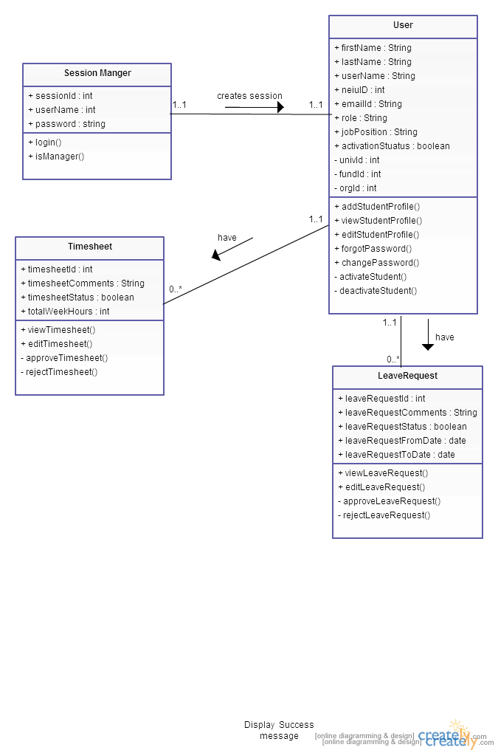

# Dynamic Models

## Activity Diagrams

### *Activity Diagram 0* – Create Student Worker Profile

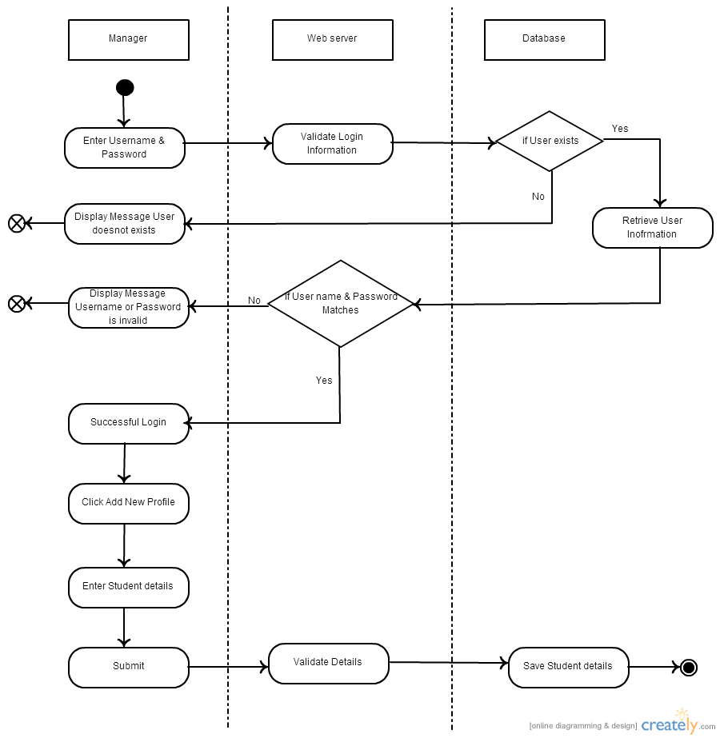

### Activity Diagram 1– View Student Worker Profile

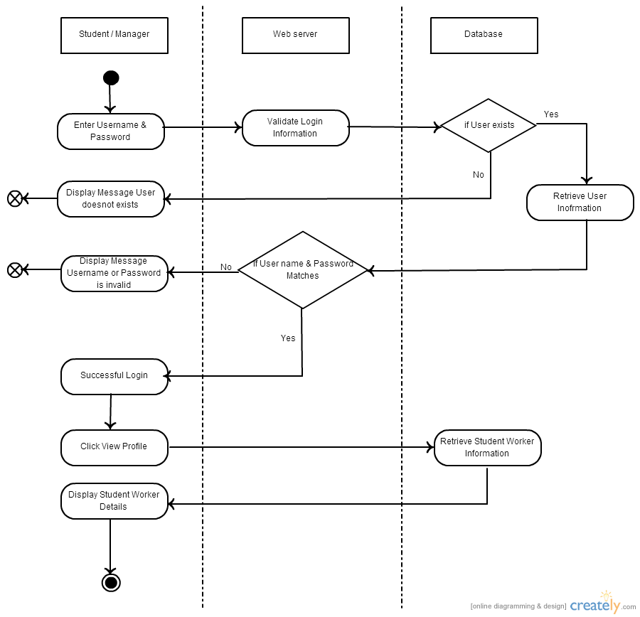

### Activity Diagram 2 – Edit Student Worker Profile

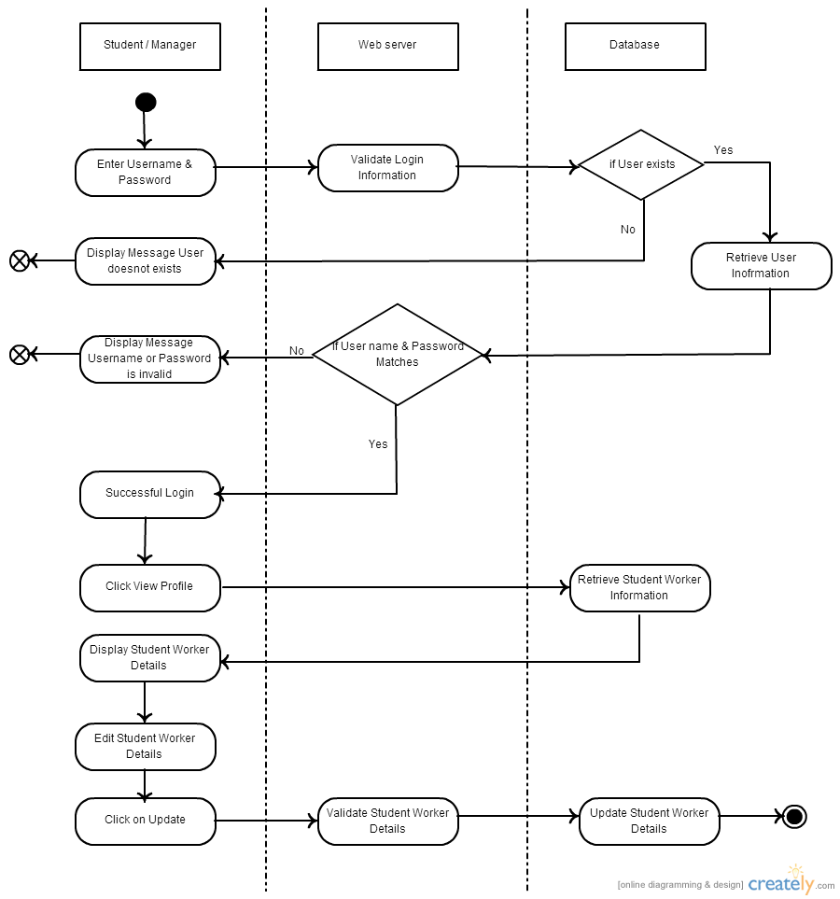

### Activity Diagram 3 – Activate Student Worker Profile

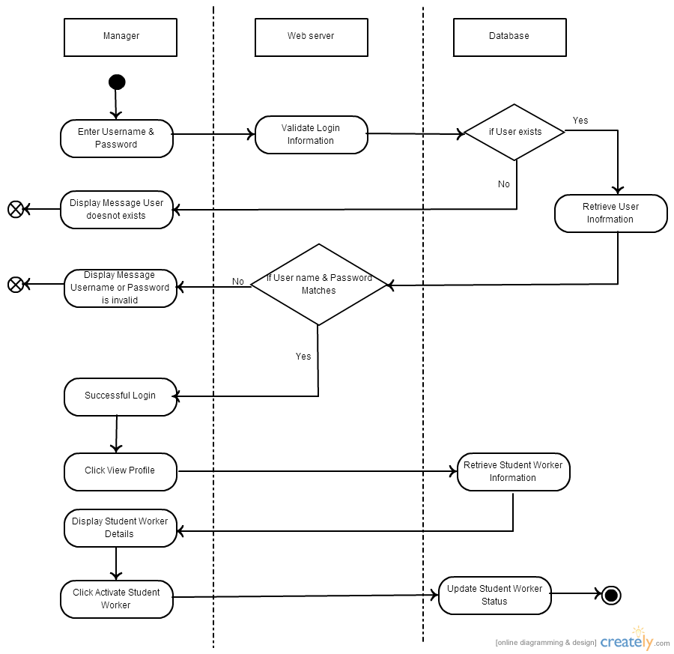

### Activity Diagram 4 – Deactivate Student Worker Profile

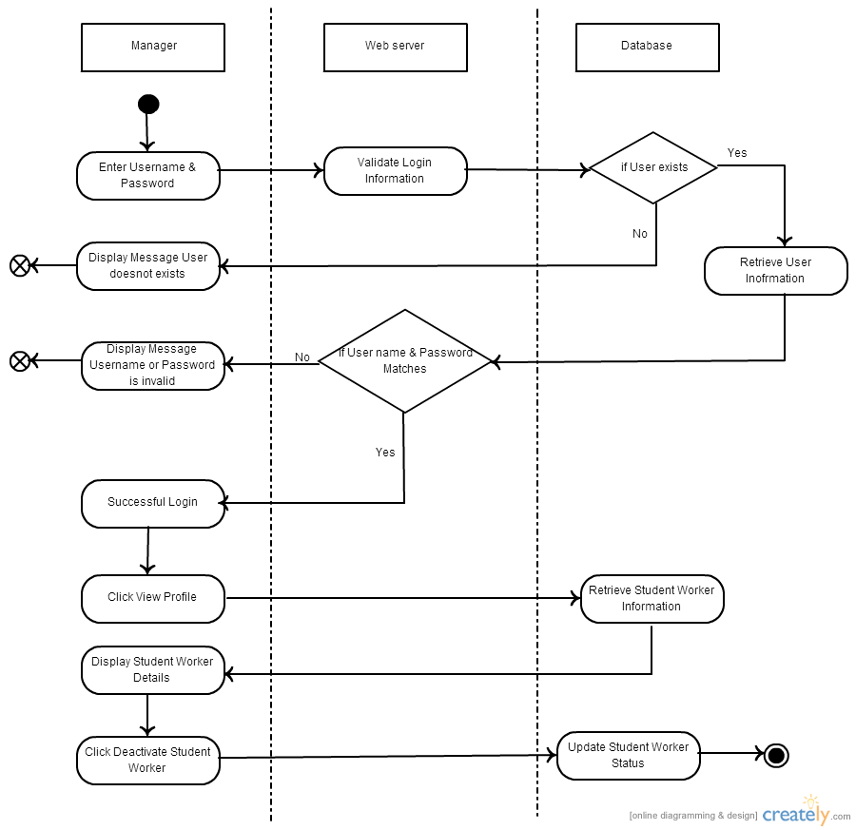

### Activity Diagram 5 – Login

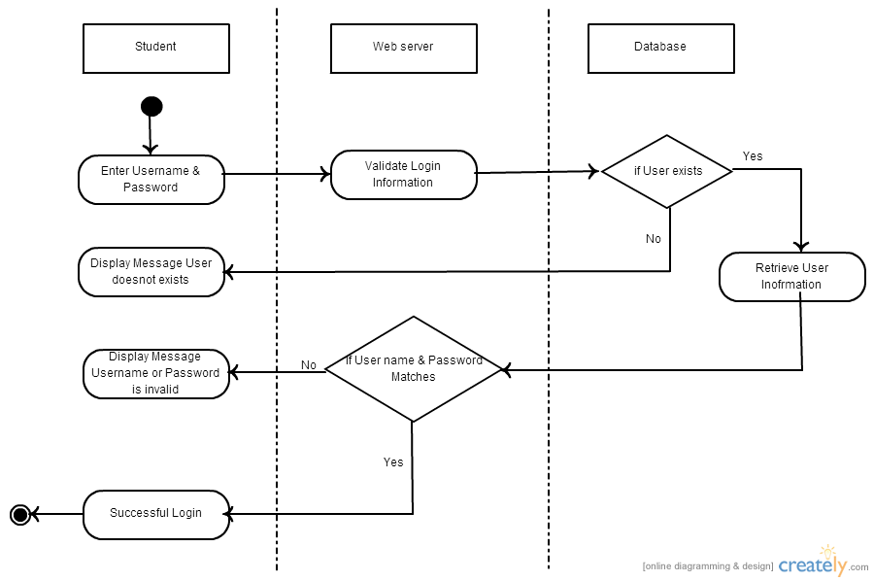

### Activity Diagram 6 – Change password

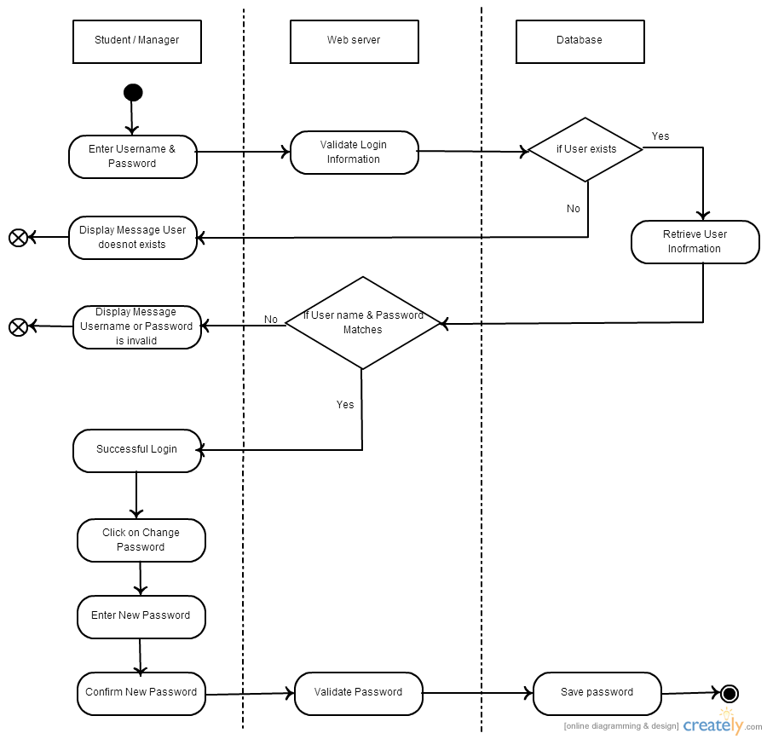

### Activity Diagram 7 – Forget Passowrd

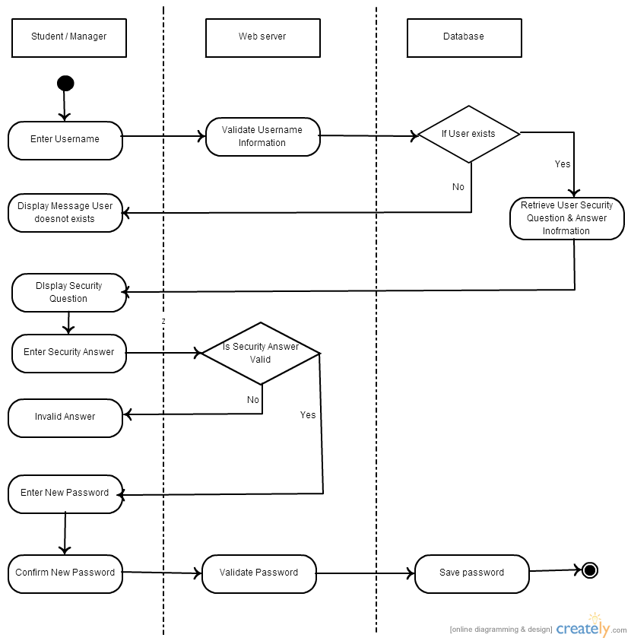

### Activity Diagram 8– Timesheet

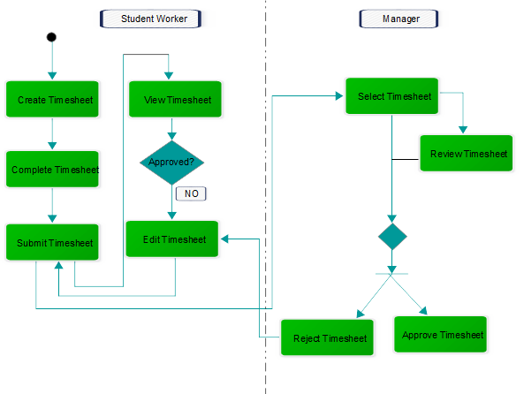

### Activity Diagram 9– Leave Request

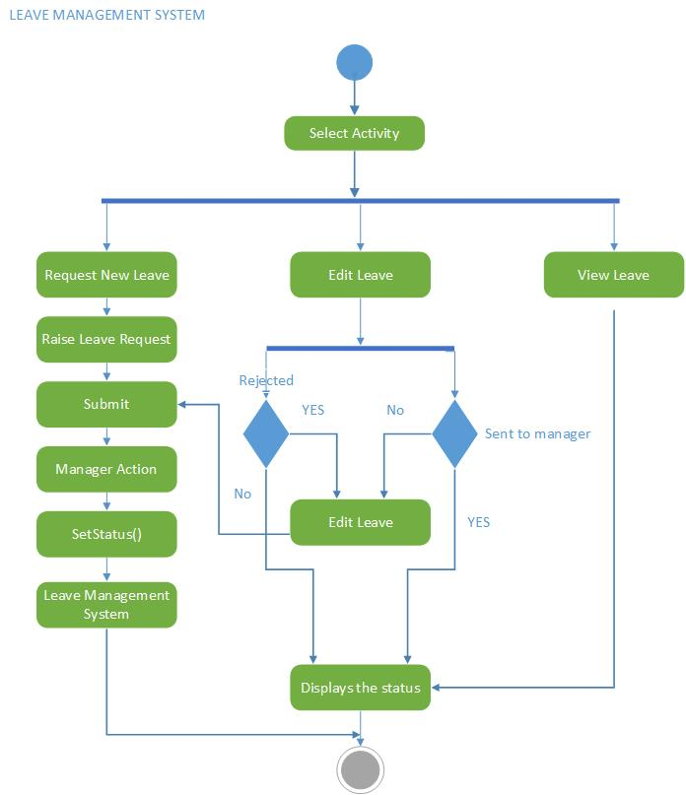

### Activity Diagram 10 – Approve Leave Request

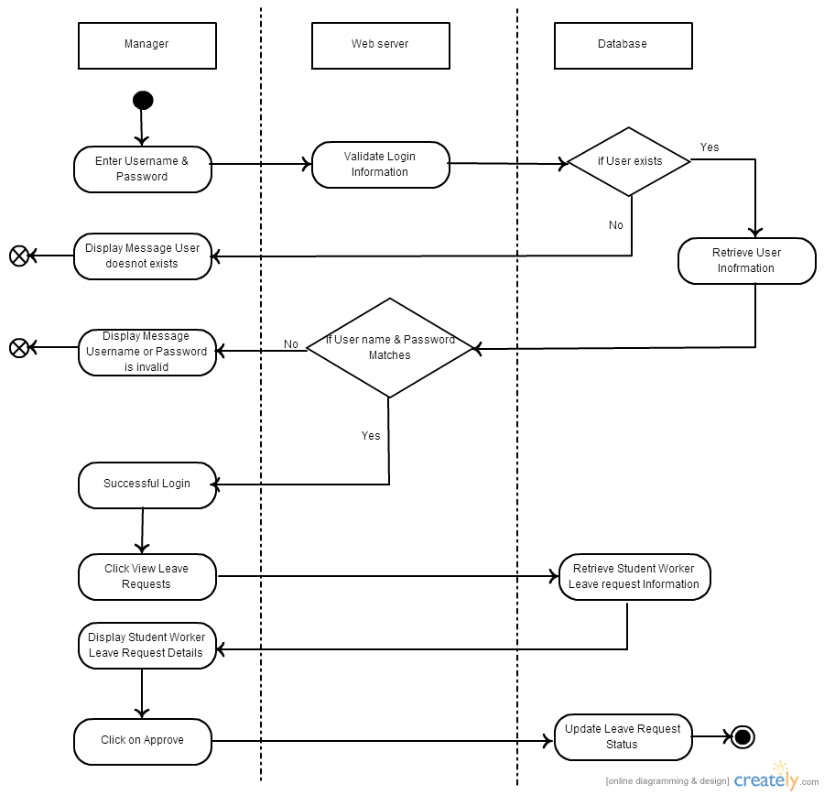

### Activity Diagram 11 – Reject Leave Request

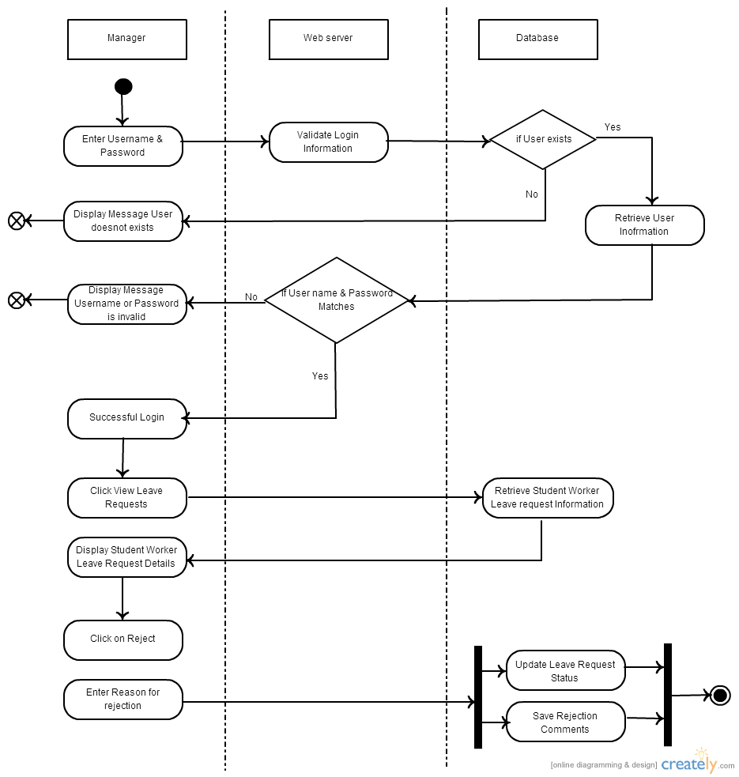

## Sequence Diagrams

### Sequence Diagram 0 – Manager View & Edit Profile(Module 0)

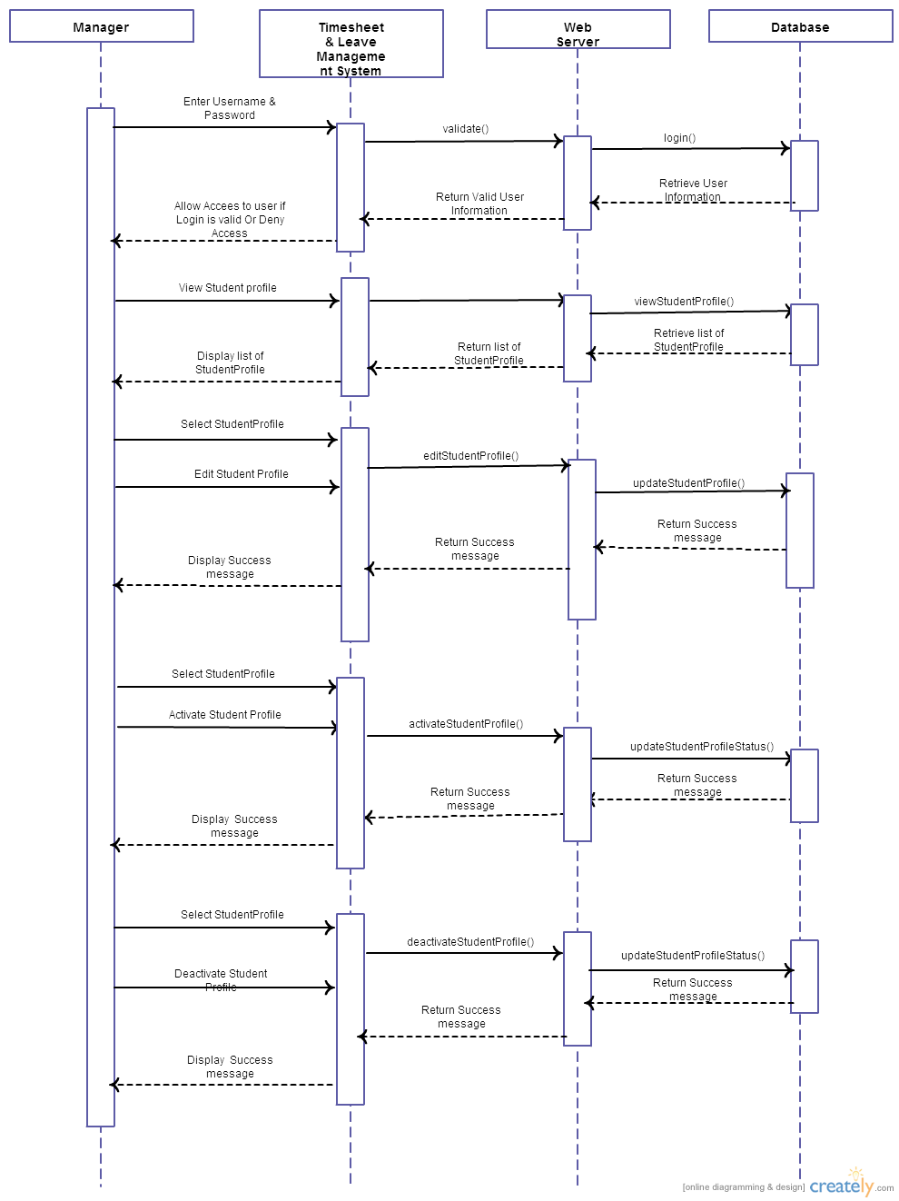

### Sequence Diagram 1 – Student worker View & Edit Profile(Module 0)

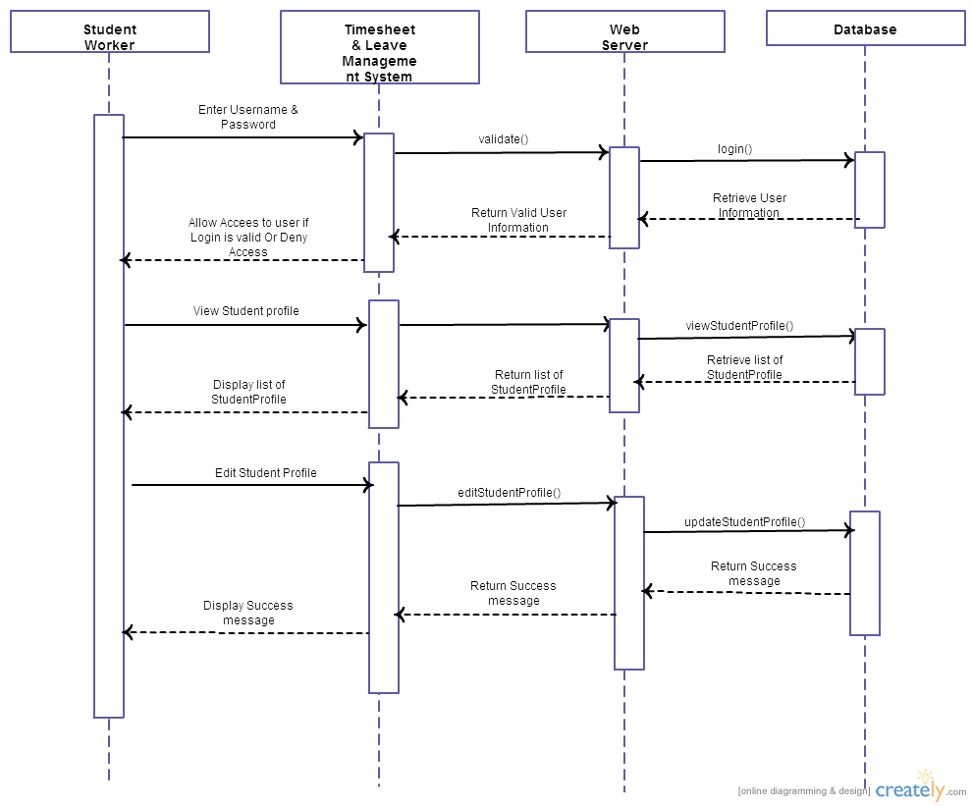

### Sequence Diagram 2 – Login(Module 1)

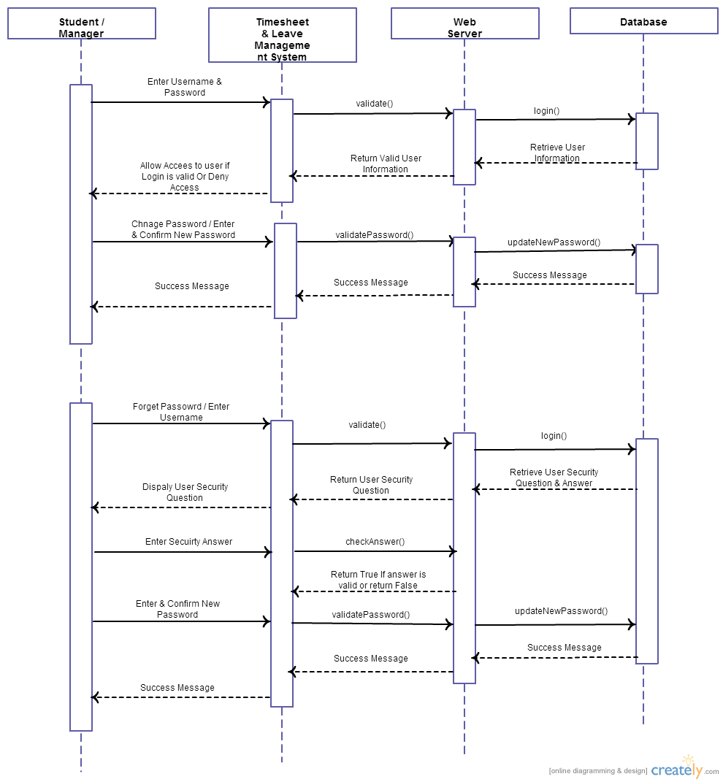

### Sequence Diagram 3 – Timesheets(Module 2&4)

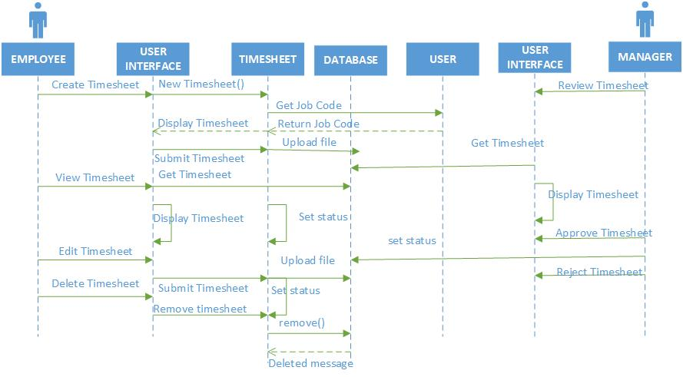

### Sequence Diagram 4- Leave Management(Module 3)

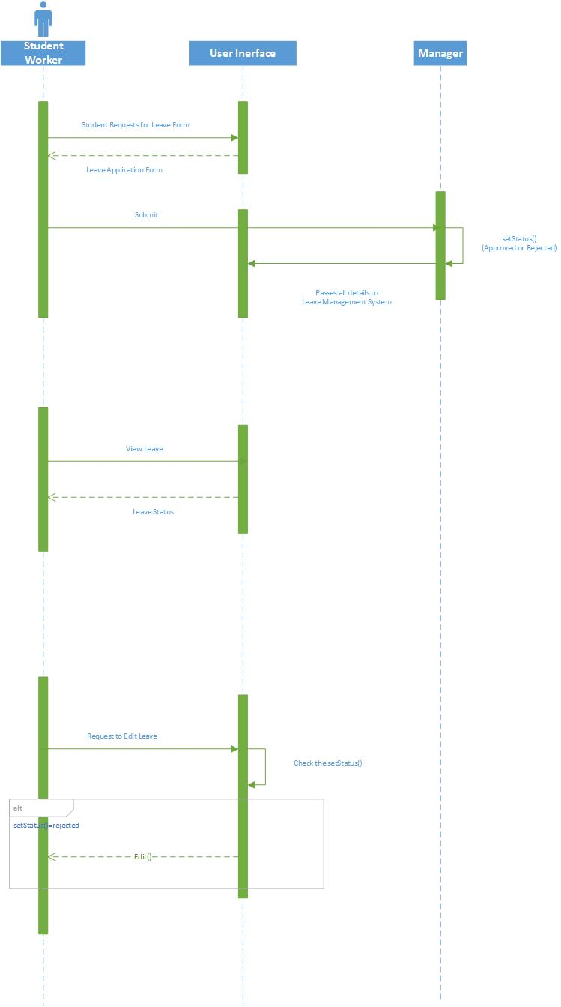

### Sequence Diagram 5 – Approve/Reject Leave Requests(Module 5)

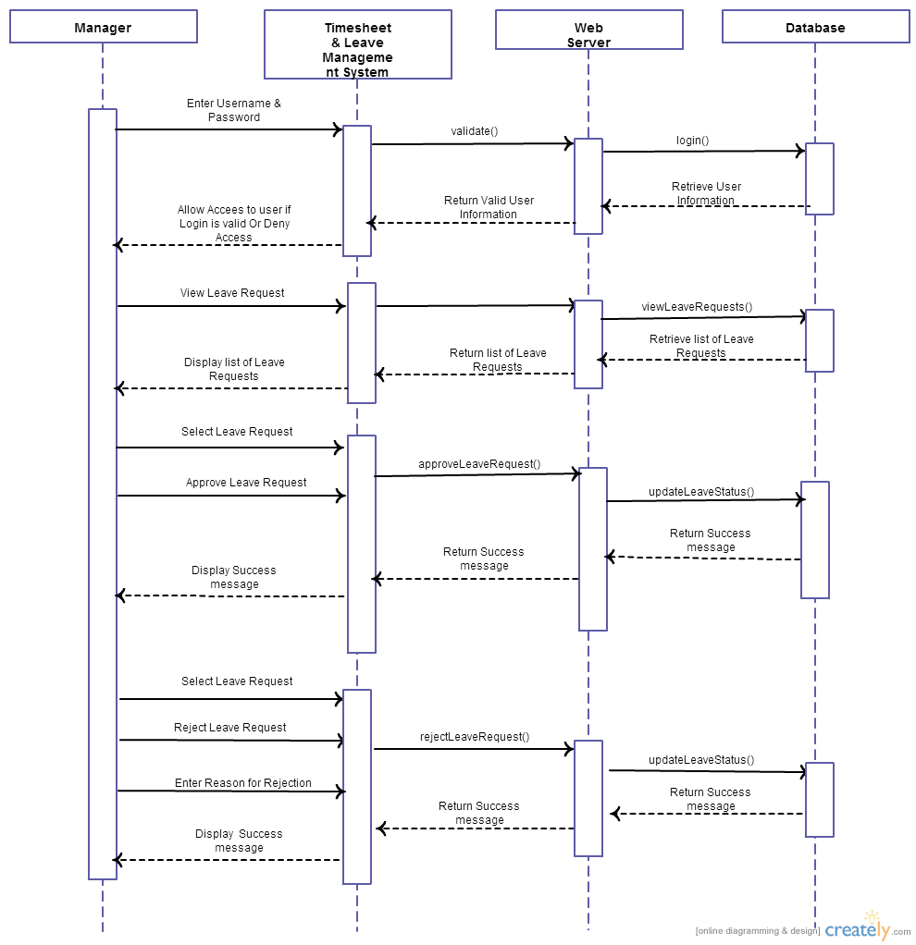

# Data Design

## Entity Relationship Diagram

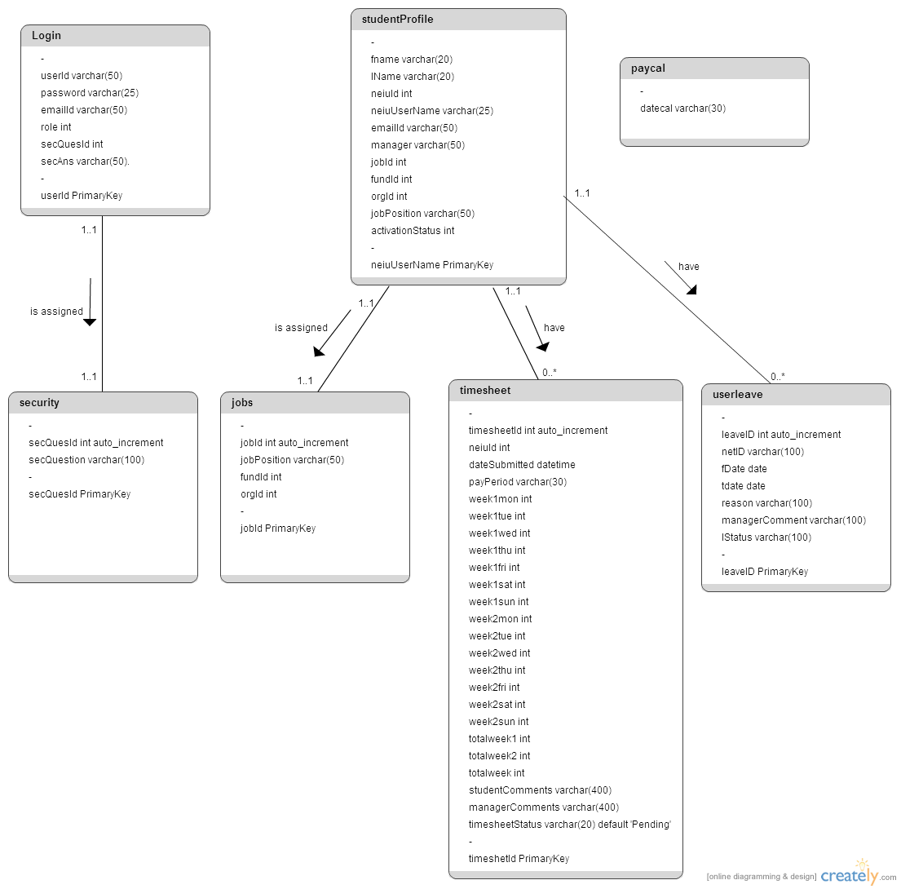

The above diagram depicts the relationship between different entities (tables) in the timesheet & leave management system*.* Below mentioned are tables in T&L System:

1. Login: This table stores the username, password and security question and answer details of a particular user which are used for logging into the system.
2. Student Profile: This table stores all the student worker personal and job related information which are added by manager of that student. It also stores the activation status of the student.
3. Timesheet: This table stores the number of hours entered by a student for each day of a week for two weeks and also the status of timesheet whether it is approved or rejected by the manager along with his comments.
4. User Leave: This table stores the leave request details raised by a student like from date, to date, reason for leave, status of approval of leave and manager comments
5. Security: This table stores the list of security questions that are assigned to a user which is used for authenticating the user when they forget password.
6. Jobs: This table stores the list of jobs and their details like fund id, org id that can be assigned to student worker by his manager.
7. Paycal: This table stores the list of dates for pay period used for submitting timesheets.

Below is the description of relationships between entities mentioned above:

* Each user in login **is assigned with** one and only one security question which is to be answered by him to authenticate while he forgets password.
* Each student worker **is assigned with** one and only one job by his manager while creating his profile.
* Each student can **have** zero or more number of timesheets created and sent for approval.
* Each student can **have** zero or more number of leave requests created and sent for approval.

# Non Functional Requirements

## Ease of Use

Following initial login, the system interface includes a navigation bar for easy access to those modules that the student worker or manager has access to. All the menu items will clearly indicate the operations that can be performed. Logging out should involve only one click. Site navigation will be available at all times in the bottom of every page to facilitate easy navigation.

## Reliability

Student workers and Managers will require access to the system 24 hours a day, 7 days a week. Initial login should take no more than three seconds. System maintenance should be kept to a minimum (once every three months for upgrades/ fixes) and should require no more than 48 hours. Ideally, maintenance should take place over holiday weekends when system access is off peak.

## Security

Student access should be restricted to the individual student’s information only; no student will be allowed to access any other student’s information. Manger access should be restricted to information pertaining to those students workers for which they are responsible. Student workers and Managers can access only those modules for which they are authorized (i.e.: a student worker will not be able to approve or reject timesheets or leave requests that are to be performed by a manger.) Password requirements should be strictly enforced to prevent unauthorized access.

# Supplementary Documentation

This section describes the tools used for diagrams and any templates used for documentation

## UML Diagrams

1. Creately Online tool – <http://creately.com/>
2. Microsoft Visio

## Entity Relationship Diagram

1. Creately Online tool – <http://creately.com/>

## Naming Conventions

While designing the system, we as team agreed upon using standard naming conventions to be followed while developing the system.

|  |  |
| --- | --- |
| Java Package Names | All lowercase letters. Should not start with numbers or _ |
| Java Class Names | Starts with uppercase letter and each other word in the name starts with uppercase letters. Should not start with numbers or _ |
| HTML or JSP pages names | Starts with lowercase letter and each other word in the name starts with uppercase letters. Should not start with numbers or _ |
| Database table names | Starts with lowercase letter and each other word in the name starts with uppercase letters. Should not start with numbers or _ |